**What is ECS ?**

* Amazon Elastic Container Service (Amazon ECS) is a highly scalable, fast container management service that makes it easy to run, stop, and manage containers on a cluster.
* A service is a configuration that enables you to run and maintain a specified number of tasks simultaneously in a cluster.
* Your containers are defined in a task definition that you use to run individual tasks or tasks within a service. In this context,. You can run your tasks and services on a serverless infrastructure that is managed by AWS Fargate.
* Alternatively, for more control over your infrastructure, you can run your tasks and services on a cluster of Amazon EC2 instances that you manage.

You can schedule the placement of your containers across your cluster based on your resource needs, isolation policies, and availability requirements. With Amazon ECS, you don't have to operate your own cluster management and configuration management systems or worry about scaling your management infrastructure.

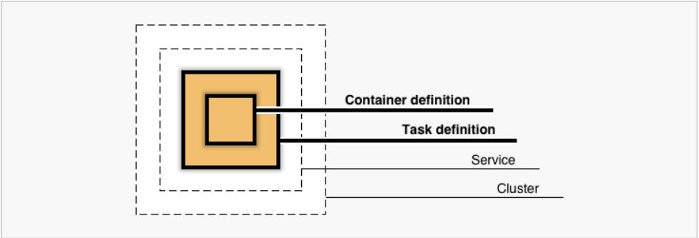

**Features of Amazon ECS**

* Amazon ECS is a regional service that simplifies running containers in a highly available manner across multiple Availability Zones within a Region.
* You can create Amazon ECS clusters within a new or existing VPC.
* After a cluster is up and running, you can create task definitions that define which container images run across your clusters. Your task definitions are used to run tasks or create services.
* Container images are stored in and pulled from container registries, for example, the [Amazon Elastic Container Registry](https://docs.aws.amazon.com/ecr).

**Fargate Architecture**


                Diagram showing architecture of an Amazon ECS environment using the
                    Fargate launch type.
            

**Containers & Images**

* To deploy applications on Amazon ECS, your application components must be architected to run in containers.
* A container is a standardized unit of software development that contains everything that your software application needs to run, including relevant code, runtime, system tools, and system libraries. Containers are created from a read-only template called an image.
* Images are typically built from a Dockerfile, which is a plaintext file that specifies all of the components that are included in the container.
* After being built, these images are stored in a registry where they then can be downloaded and run on your cluster. For more information about container technology, see [Docker basics for Amazon ECS](https://docs.aws.amazon.com/AmazonECS/latest/developerguide/docker-basics.html).


                    Diagram showing Docker image creation and registration within an Amazon ECS
                        environment.
                

**Amazon ECS Cluster**

An Amazon ECS cluster is a logical grouping of tasks or services.

You can register one or more Amazon EC2 instances (also referred to as container instances) with your cluster to run tasks on them.

auOr, you can use the serverless infrastructure that Fargate provides to run tasks. When your tasks are run on Fargate, your cluster resources are also managed by Fargate.